Standard Data Logging Practices

# Overview

The purpose of this document is to detail a proposed standard to documenting engine log events. This standard seeks to address several perceived short comings in current practice that have negatively impact our capacity to pursue a data-driven design for our vehicle. Specifically, the standard seeks to:

* Capture information regarding the current configuration (Suspension parameters, Tune used, components used) of the vehicle/ dynamometer
* Standardize the format of fields (Driver, venue, event,) to enable easy sorting and identification of log files
* Documentation of failures and failure severity that is directly tied to the log file
* Eliminate the logging of faultily/broken/configured sensors
* Record track and atmospheric conditions

# MoTeC Logged Details

|  |  |
| --- | --- |
| Field Name | DESCRIPTION |
| Event | Event Type Identifier |
| Venue | Physical Location |
| Engine ID | Filename of Tune used |
| Vehicle ID | Filename of Configuration Excel File |
| Driver | Net ID of Driver/Operator |
| Session | Identifier of Subteam and Responsible Tester |
| Start Lap | Test Report Code |
| Short comment | Test Status Code |
| Long Comment | Additional details pertaining to test conditions |

## Event

## The purpose of the event field is to generally categorize the type of test being run.

The following event type identifiers are allowed:

|  |  |
| --- | --- |
| Event Type Identifer | DESCRIPTION |
| Accel | Used for tracks representative of the acceleration event |
| autox | Used for tracks representative of the autocross event |
| Endur | Used for tracks representative of the endurance event |
| skid | Used for tracks representative of the skid pad event |
| Hold | Used for engine rpm holds conducted on the dyno |
| Sweep | Used for engine rpm sweeps conducted on the dyno |
| warm | Used for logs relating to warming up the engine |
| Other | Used for logs not of the above type |

When the identifier “OTHER” is used a description of the track shape or dyno test is required in the long comment.

## Venue

The purpose of the venue field is to identify the physical location when the data was collected. In order to ensure that all physical locations can be uniquely identified only use the below identifiers. If a new testing location is used, a new identifier will be created.

|  |  |
| --- | --- |
| Venue | Description |
| BLot | B Parking Lot at Cornell |
| DYno | Used for all dyno testing |
| LAB | At or outside the GM Lab |
| MIS | Michigan International Speedway |
| GLEN | Watkins Glen International Racetrack |
| Destiny | Destiny USA Mall Parking lot |
| Groton |  |

## Engine ID

The purpose of the engine ID is to identify the active tune configuration by documenting the filename of the tune file used. In order to ensure each tune configuration is uniquely identified, any changes to the tune file must be saved under a new filename.

## Vehicle ID

The vehicle ID contains the filename of the excel document set up as a “MoTeC Setup worksheet”. The following is the required format of the file

### First Sheet: Suspension

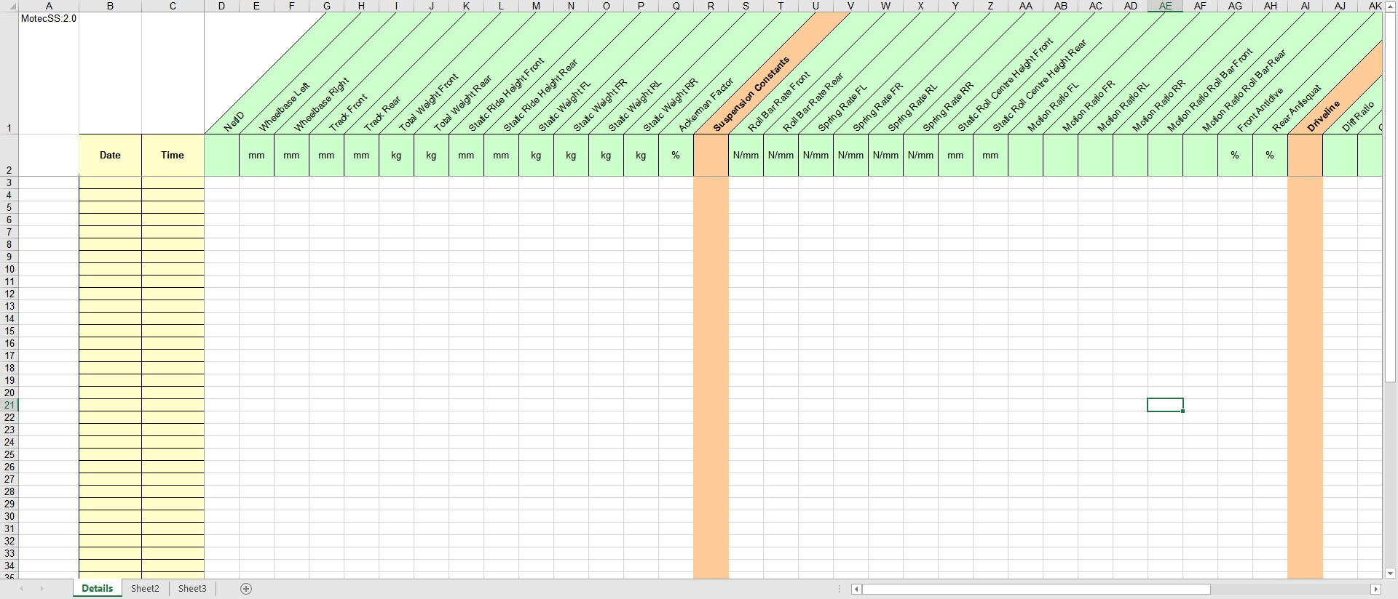

* Cell A1 contains: “MotecSS:2.0” exactly
* Column B and C the date and time when each suspension set up occurred
* Row 1 contains the Parameter Name and Row 2 contains the unit of the parameter
* The first parameter listed is the NetID of the person in charge of the suspension set up

### Second Sheet: Components

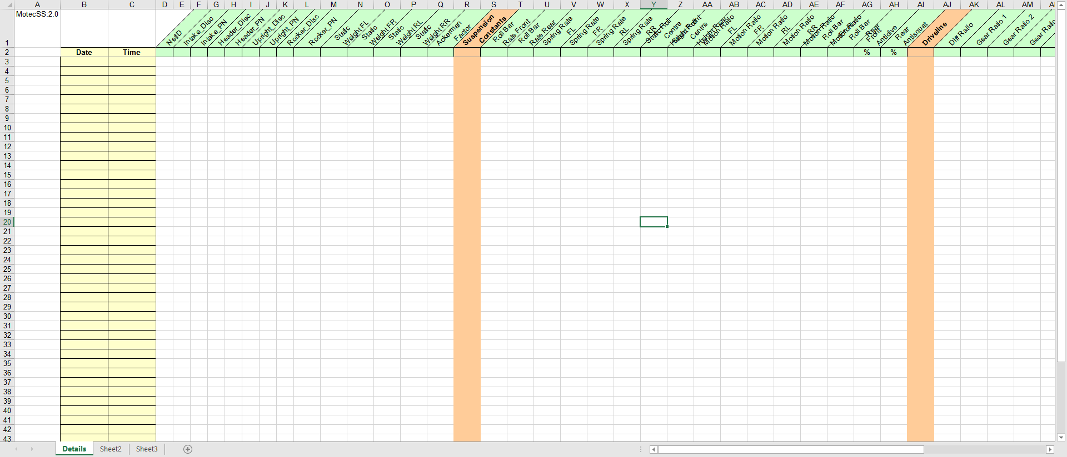

* Cell A1 contains: “MotecSS:2.0” exactly
* Column B and C the date and time when a component change occurred
* Row 1 alternates between the component description and part number
  + ComponentName_Disc: A description the component ie. ARG17 Log Intake
  + ComponentName_PN: The Part number of the component ie. FL17 A04
* The first parameter listed is the NetID of the person in charge of the component change

### Updating Configuration

Only parameters that have changed need to be recorded in a given row for example say the engine was set up with the ARG17 Intake manifold.

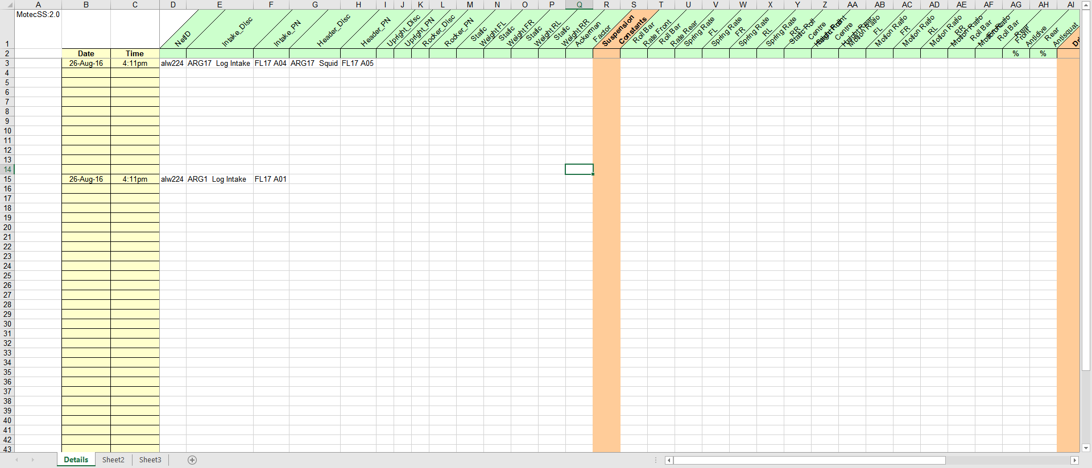

If I then swapped the intake manifold to the ARG16 manifold, I would add a new row as such:

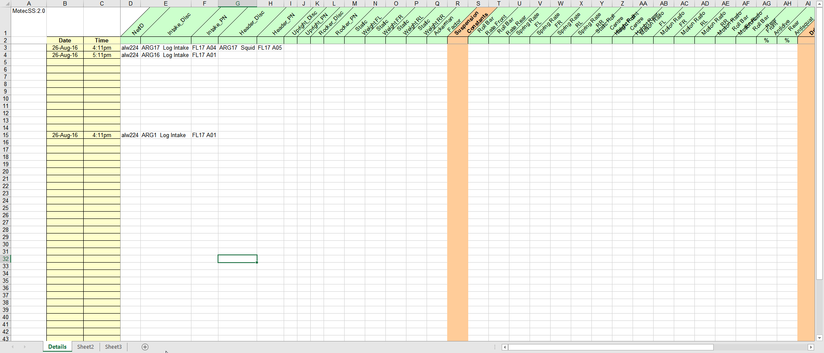

Notice that I only changed included what was changed in the new row and not every component on the car.

## Driver

The NetID (i.e. alw224) of the person actively driving the car or the lead operator of the dyno. Multiple NetID’s are only allowed during events at competition where data cannot be taken between drivers. In that case the first driver’s netid will be listed followed by the second drivers netid (i.e. alw224 wla422)

## Session

The purpose of session is to identify the subteam and individual actively responsible for the current test. The format for session is: “Subteam NetID”, for example “Flow alw224”. For consistency only the following identifiers can be used for each subteam. If a new subteam identifier is needed it should be added to the list below.

|  |  |
| --- | --- |
| Identifer | Subteam |
| Drive | Used for driver training |
| Dyno | Used for dyno testing explicitly for the dyno team |
| FLOW | Used for testing conducted for the Flow subteam |
| AEro | Used for testing conducted for the Aero subteam |
| Ergo | Used for testing conducted for the Ergo subteam |
| UnSprung | Used for testing conducted for the Unspring subteam |
| DTrain | Used for testing conducted for the drivetrain subteam |

Note: The subteam listed is the subteam that has requested the testing regardless of who actually conducts the test

|  |  |
| --- | --- |
| Case | NetID to USe |
| Driving Day | Head Driving Instructor |
| Dyno TUning | Head Dyno Operator |
| Testing for a Subteam | Individual who authored the test report |

In general, the netid used is for the person responsible for the test currently conducted

## Start Lap

The name of the Test Report currently being followed

## Short Comment

The purpose of the short comment is to quickly indicate the present of any component/ system faults that occurred during the current logging period. It is not mean to be an indicator of whether the underlying date is “good” or “bad”.

If not faults occurred during the logging period, the short comment is: “Good Test”. Otherwise the short comment takes the form: “System_Severity”. For example: a thrown rod would be “ENG_CAT”, while low tire pressure would be “CHA_ISU”.

The following system identifiers can be used:

|  |  |
| --- | --- |
| System Identifer | MEaning |
| ENG | Fault is related to the Engine |
| CHA | Fault is related to the Chassis |
| EE | Fault is related to the electronics |

The following severity codes can be used:

|  |  |  |  |
| --- | --- | --- | --- |
| Code | SeveritY | Type of Fault | Example |
| ISU | Issue | Standard Maintenance Required | Out of Fuel |
| FAIL | Failure | Component requires attention | Headers leaking exhaust gas |
| CAT | Catastrophic | Component requires replacement | Rockers buckling |

## Long Comment

The purpose of the Long comment is to provide a detailed summary of the test and document additional test conditions not captured elsewhere. The first section of the Long Comment is the header which contains:

* Explanation of the Short Comment if not “Good Test”
* Explanation of the Event if “Other”
* General Comments on the test

After the Header comes a series of entries detailing additional information related to the track. Each entry starts on a newline and starts with “ParameterName:” followed by the information being logged. For example:

Air Temp: 25 C

The following parameters are to be included in every log fie related to driving the car:

|  |  |
| --- | --- |
| Parameter | DESCRIPTION |
| Air Temp | Temperature of the air in degrees Celsius |
| Humidity | Percent humidity of the air |
| Wind | Wind speed in m/s and heading (N,NE,E,…) |
| Weather | Brief description of the weather (Sunny, rain, …) |
| Track Temp | Temperature of the track surface in degrees Celsius |
| trACK wETTNESS | How wet the track is: Wet, Damp or Dry (Choose one) |

Units are required for all measured entries (ie. Air Temp).

## Example Details:

